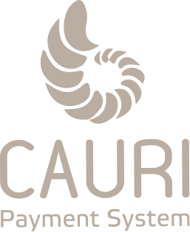

The Declaration of basic values and key principles for the development of CAURI

CAURI is a financial institution registered in UK, licensed to provide financial services to companies and individuals.

The very first business of CAURI was the acceptance of Internet payments for any form of electronic commerce and payments to bank cards of individuals.
In the spring of 2018, payment accounts, which have the full functionality of a bank current account, were added to it. The CAURI product line continues to expand.

Our goal is to build an international Internet bank for trading companies.
The areas we work in today are endless. This means that the possibilities for expanding our business also have no limits.

What are we better than others? Attitude to business.
We always do a little more than what is required of us. We always move forward and surpass ourselves.
The peculiarity of each company is how it is able to present its services to the client, what language it speaks and how it builds relationships with him. Our client receives only what he needs, what is valuable for him and that is what makes us unique.
Every day we confirm our reliability and quality - with our work, sensitive attitude, uncompromising in terms of quality and filigree of details.
When we say that a company is reliable, we are talking about a holistic picture of a reliable and complex mechanism. About the mechanism on which you can rely, to which you can entrust your funds, with the help of which it is easy to carry out daily operations, where trust is an integral part of a relationship.
In such a company, everything works properly: starting with a secretary who greets you at the entrance with a smile, and ending with the top management involved in the work of the company at all levels. All the mechanisms are working neat and smooth.
However, such a complex mechanism could not function effectively without reliable support of the mainstay of our company, with what it all begins and all ends, - our people.
Professional, disciplined team that proves that you can rely on it in any challenge.
Materials, facilities and even coffee served again and again testify to our attitude, perfectionism and readiness to fulfill any wishes of the client.
And, of course, the reliability of information systems in our electronic age is the cornerstone of high-quality and secure service.
At the same time, it is only a frame, an addition to the most important thing - our employees.
Experience, professionalism and attitude to work and clients - this is a distinctive feature of CAURI. It is these qualities that make everything alive and active around.

In our company, efforts, new interesting ideas and impeccable attitude to work are greatly appreciated.
At CAURI, we are committed to the symbiosis and harmony of digital solutions with human relationships and intelligence.
We are the team that always keeps its word. The team that takes responsibility, the employees who understand that they are in business, who think not from the category of observer, but from the category of action: we do, we will do. The team that works for the result.

We are proud of what has been achieved and are moving towards even greater success.

